Software Requirements Specification

Version 1.0

Jan 22, 2016

IIITG Bus Reservation System.

Vaibhav Bhuwan

Submitted in partial fulfillment

Of the requirements of

CS 330 Software Engineering

This work is based upon the submissions of the Winter 2015 CS 330. The students who submitted this team projects is Vaibhav Bhuwan.

Table of Contents

Table of Contents 3

List of Figures 4

1. Introduction 5

1.1 Purpose 5

1.2 Scope of Project 5

1.3

1.4

1.5

2. Overall Description

2.1

2.2

2.3

2.4

2.5

2.6

2.7

3.

3.1

3.2

3.3

3.4

4.

4.1

4.2

5.

5.1

5.2

5.3

5.4

5.5

6. Other Requirements

Appendix A: Glossary

Appendix B: Analysis Models

Appendix C: To Be Determined List

# List of Figures

Figure 1 – Use Case Diagram 6

Figure 2 – Class Diagram 6

Figure 3 -

Figure 4 -

# Introduction

* 1. *Purpose*

The purpose of this document is to present a detailed description of the IIITG Bus Reservation System. . It will explain the purpose and features of the system, the interfaces of the system, what the system will do, the constraints under which it must operate. This document is intended for both the stakeholders and the developers of the system.

* 1. *Scope of Project*

The software system will be a Bus Reservation System for Indian Institute of Information Technology, Guwahati. This system will help students as well as staff and faculty members of IIITG to see the timing and status of bus and accordingly they can plan their journey. This system will keep records of all the journey history of a user. It will have a relational database system which will keep all the record of user, source station, destination station, mode of payment, email id, phone no, seat no etc.

It will save the time as well as require less maintenance for both users as well as stackholder.



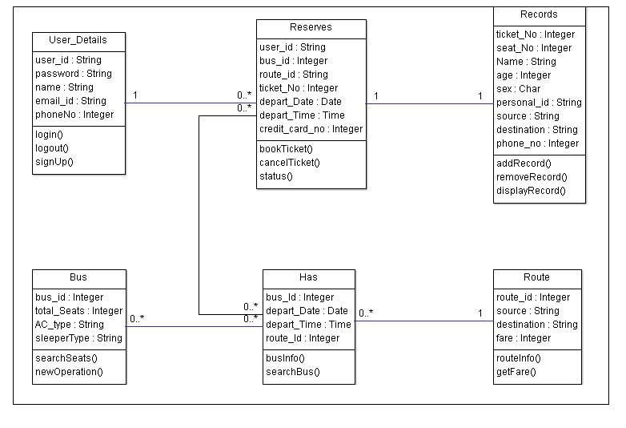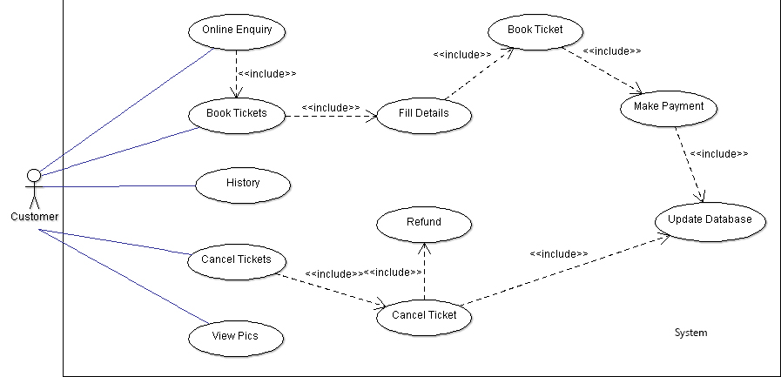

Fig. 2 : Class Diagram

Fig. 1 : Use Case Diagram